Támaszpont MOP KKA
2015
COMPREHENSIBLE INPUT IN YOUTH WORKER MOBILITY
Infopack of Learning Mobility of Individuals KA1 – Seminar for youth workers.
Támaszpont Mentálhigiénés Oktatási és Prevenciós Kiemelten Közhasznú Alapítvány
2112 Veresegyház Kútfő u.18 Hungary
+ 36 30 432 4204+ 36 30 553 2381
tamaszpont.mop.kka@gmail.com

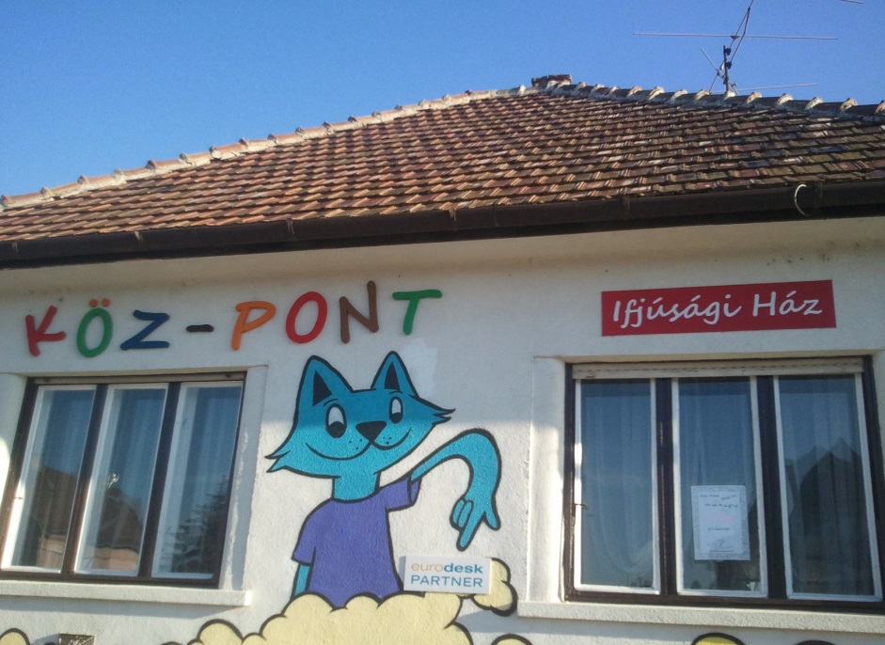
About us
Támaszpont MOP KKA is an NGO working with a lot of different volunteers from the town.
We organize programmes based on community resources, providing pleasant and useful leisure time activities for young people aged 12-25. We strengthen their ability to protect themselves against negative social processes; we attempt to reduce deficits arising from social and cultural differences through the development of individual and community competencies. Our direct target group consists of young people aged 12-25 living in our town and the small region.
We are getting together to develop a competitive, comprehensive methodology for trainers to assist them in teaching students via languages. We strongly believe that the methods through the language/s will help create better understanding of other subjects leading towards civics and moral responsibilities and strong allegiance towards the community. Be it the country or Europe or even our beautiful blue planet. Through this we aim to prevent delinquency. We help to our volunteers to can deal with young people adequate and they help to the kids.
We sow the seeds of interest, we let grow the tree of curiosity AND we reap the fruits of success.

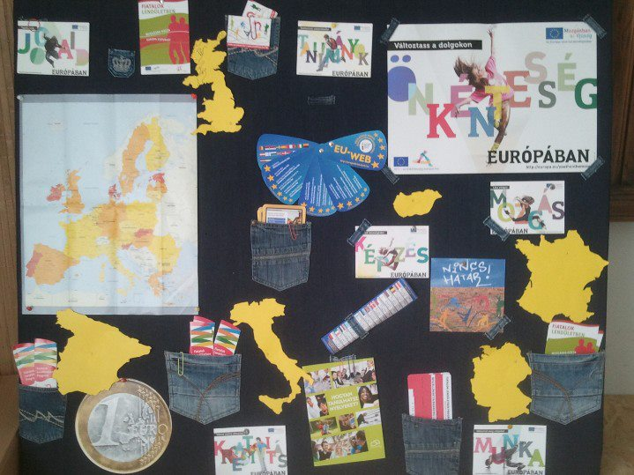
Main Activities
- The following services are available free of charge in Köz-Pont Ifjúsági Ház: coaching, games, possibility to meet friends, „protected hanging around”
out of school tutoring on various subjects, individual consultancy (psychologist, occupation orientation, healthy food), information on local events
- Thematic programs every fortnight (drama pedagogy, autognosis, creative programs, sporting facilities, social games, development of foreign language skills)
- Training of peer helpers
- Events: Ifjúság Napja (Youth Day), Ifjúság hete (Youth Week), Föld Napja (Earth Day)

Comprehensible Input in Youth Worker Mobility

Seminar
Comprehensible Input (CI) is a research based approach to teaching and learning languages. While practiced worldwide (especially in the USA) by thousands of teachers of various languages, it has only a small number of practitioners in Europe.
The method called TPRS (Total Physical Response Storytelling, aka Storyasking) is perhaps the most sophisticated practical application of the approach, readily applicable to the short term language instruction provided to youth workers before they start working in a new country. We want to provide you with a basic understanding of the whys and, at the same time, to show you how it works with the aim of raising awareness of the CI philosophy in Europe.
Beside language instructors, EVS mentors and coordinators can also use the method with their volunteers. It is also useful for youth workers who work with students with learning disabilities / specific needs. It is an excellent tool to develop transversal skills.
Aim
To increase the efficiency of short term language instruction provided to youth workers
Objectives
- To establish a common platform between organization and youth worker for long term cooperation, raising awareness of best practices in training
- To assess the role of non-formal education in participating countries
- To learn about research based new methodologies in language instruction
- To practice the application of the main principles of Comprehensible Input
- To discuss how teachers can be motivated to adopt new methodologies
- To increase the efficiency of instruction provided to students with learning disabilities
Period: 16 – 22 march 2015
Participant: 2 per organization
Partners: NGO, School, informal group or trainers

16.03.2015 | 17.03.2015 | 18.03.2015 | 19.03.2015 | 20.03.2015 | 21.03.2015 | 22.03.2015
Arrivals | Get to know each other + rules agreement | Team building games | Workshops - Revolwing Stage Part 2 | sightseeing in Budapest | Projects planning Session 1: youth exchange, training, or bigger projects in KA2, networks building | Final Evaluation
 | Introduction of project, aim and objectives, expectation and fears | Workshops - Revolwing Stage Part 1 |  |  | Projects planning Session 2: youth exchange, training, or bigger projects in KA2, networks building | Departures
 | Presentation of the national situation of teaching and learning of languages |  | sightseeing (Bear farm, lakes, Japanese garden and buildings) | How can we plan new projects for next deadline KA1 or KA2  Competition of Ideas | Presentation of the projects
Get to know each other | Welcome party | Intercultural night | Middle evaluation | Free time | Farewell Party

How to contact us?
www.tamaszpont.net
MOP KKA Támaszpont
tamaszpont.mop.kka@gmail.com
+ 36 30 432 4204
+ 36 30 553 2381

