Programme Erasmus Plus Sport- DRAFT
Project Title | Title xxxx
Topic | Erasmus Plus – Sport  “Collaborative Partnership” not related with 2015 European Week of Sport
Applicant | The Municipality of Correggio, Reggio Emilia, Italy.
Project aims | - To foster the integration between young people from different countries, cultures and different traditions through the participation into sport activities  - To promote sport as a tool for social inclusion and combat racism and violence  - To encourage participation in sport and physical activities  - To improve sharing of good practices between European municipalities in order to promote activities socially useful, and with a strong educational objectives  - To support innovative and educational approaches to support the growth of the target group within an environment ethically driven and with an healthy approach to life.
Actions | - Organization of permanent local labs network active locally in the project partners countries that bring together all sport actors involved with order to create innovative approaches to attract young people to sport and to embed sport into the education path of students.  - Organization of a “Sport Open Days”& “BarCamps” in these events kids from Italy will try different sports, young athletes will be awarded and they can find out new ways to interact and share experiences. Barcamps are based on active participation, without a pre-determined agenda of speakers. The objective is to bring people together and share knowledge. At BarCamps will participate students, teachers and families.  - Organization of a yearly Sport Forum in each partner country involved in the project with the participation of delegations from the project partners for an ongoing exchange of best practices and innovative models to approach Sport. The innovative aspects of this project are:  - participation of testimonials in the Sport Forum who will be interviewed by the participants  - focus of interest are students and young people  - Final assessment and best practice exchange in Correggio with representatives of the various Sport forum will meet in order to draw up the guidelines of teaching models used and consolidate a common model to be disseminated at European level.  - Communication and dissemination
Target Group | Age Group 8-14  We choose this specific target because represents a challenging target. In the pre-adult phase where their behaviuor should be shaped with good values and respectful attitude throug other people in society
Budget | Maximum 500.000 euro  Maximum 80% of the totale eligible costs
Contact Details | Project coordinators on behalf of Municipality of Correggio:  rita.malavasi@warrantgroup.it  jessica.carpani@warrantgroup.it

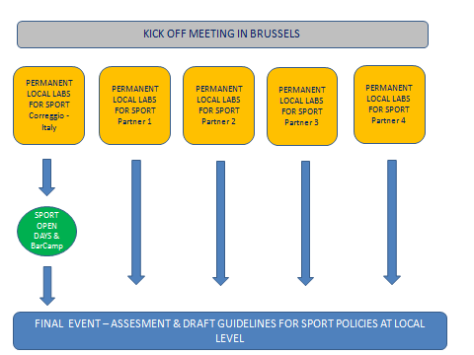
EXCHANGE OF BEST PRACTICE, SUCCESSUL PROJECTS AND INNOVATIVE METHODS

